Question 1: **Explain the CSS box model and its components(content, padding, border, margin). How does each affect the size of an element?**

**✅ CSS Box Model Explained**

* The **CSS box model** is the foundational concept for layout and spacing in web design. Every HTML element is treated as a rectangular box, and the **box model** defines how the element’s **size** and **space around it** are calculated.

**🔧 Box Model Components**

From the **innermost** to the **outermost** layer:

| **Layer** | **Description** | **Affects Size?** |
| --- | --- | --- |
| **Content** | The actual content of the box (text, images, etc.) | ✅ Yes |
| **Padding** | Clears space **inside** the element, between the content and the border | ✅ Yes |
| **Border** | A visible line around the padding and content | ✅ Yes |
| **Margin** | Space **outside** the element — pushes it away from other elements | ❌ No (unless calculating spacing between elements) |

**📐 Visual Representation**

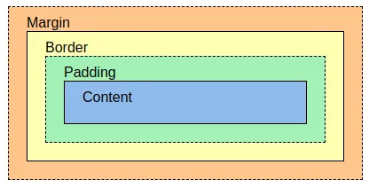

**🧮 How It Affects Element Size**

* By default (box-sizing: content-box), **total size = content + padding + border**

**Example:**

**css**

*div {*

*width: 200px;*

*padding: 10px;*

*border: 5px solid black;*

*margin: 20px;*

*}*

* Content width = 200px
* Total box width = **200 + 10 + 10 + 5 + 5 = 230px**

Note: Margin doesn't affect the element’s width/height but **affects spacing between elements**.

**✅ Alternative: box-sizing: border-box**

* With this style:

css

*box-sizing: border-box;*

* The **padding and border are included in the total width/height**.
* So:
* Width = 200px
* Content width = 200 − padding − border  
  → Makes layouts easier to manage.

Question 2: **What is the difference between border-box and content-box box-sizing in CSS? Which is the default?**

| **Feature / Behavior** | **content-box (Default)** | **border-box** |
| --- | --- | --- |
| **Definition** | Width & height apply only to the **content** | Width & height include **content + padding + border** |
| **Box-sizing area** | width = content | width = content + padding + border |
| **Padding effect** | Adds to the total size | Stays within the specified size |
| **Border effect** | Adds to the total size | Stays within the specified size |
| **Easier layout control?** | ❌ Can lead to unexpected overflows | ✅ Easier to manage fixed-width layouts |
| **Example: width: 200px; padding: 20px** | Total width = 240px | Total width = 200px (content shrinks to 160px) |
| **Common use** | Legacy, precise content sizing | Modern responsive design, consistent sizing |
| **Best practice** | Rarely preferred today | Widely used with *, *::before, *::after { box-sizing: border-box; } |
| **Example** |  |  |